**React Js Assignments**

**Module -1**

1. **HTML-CSS Login Registration page**

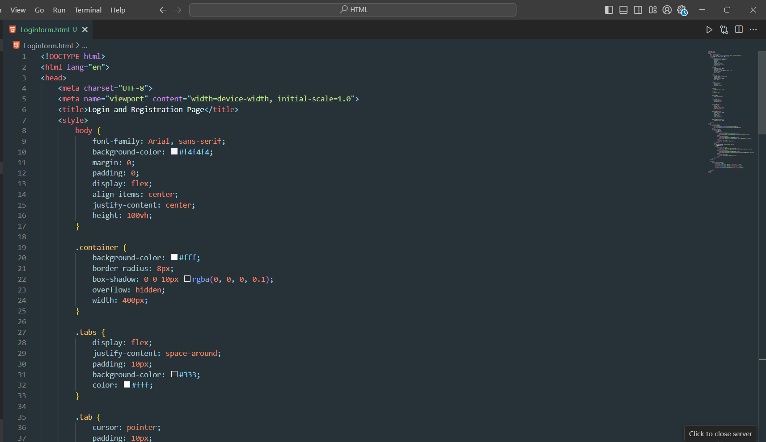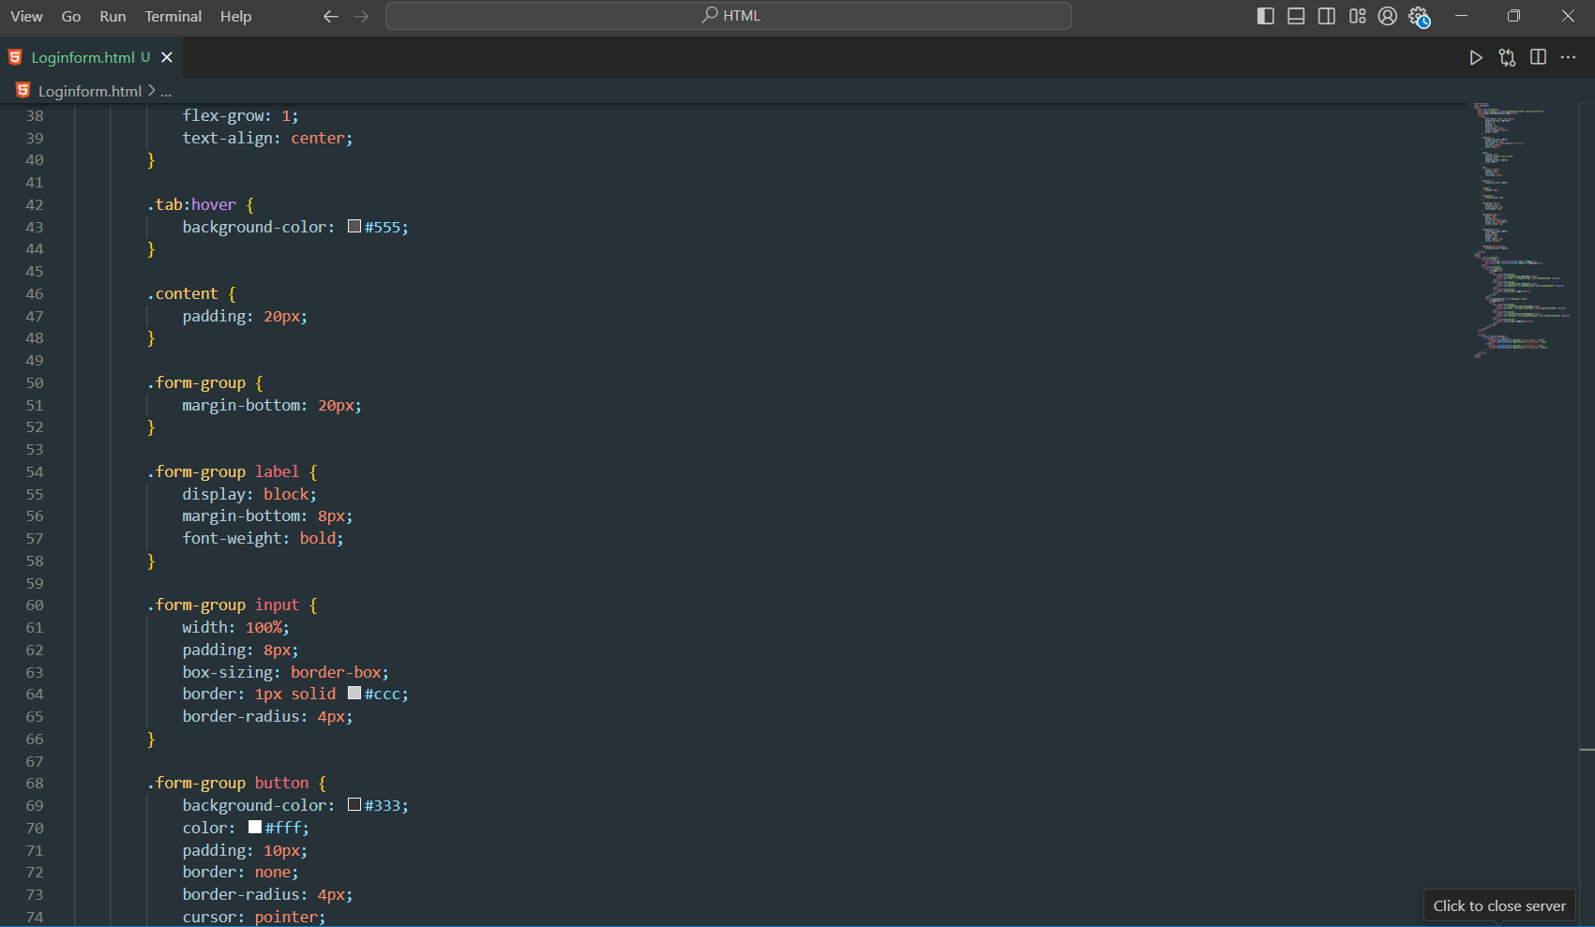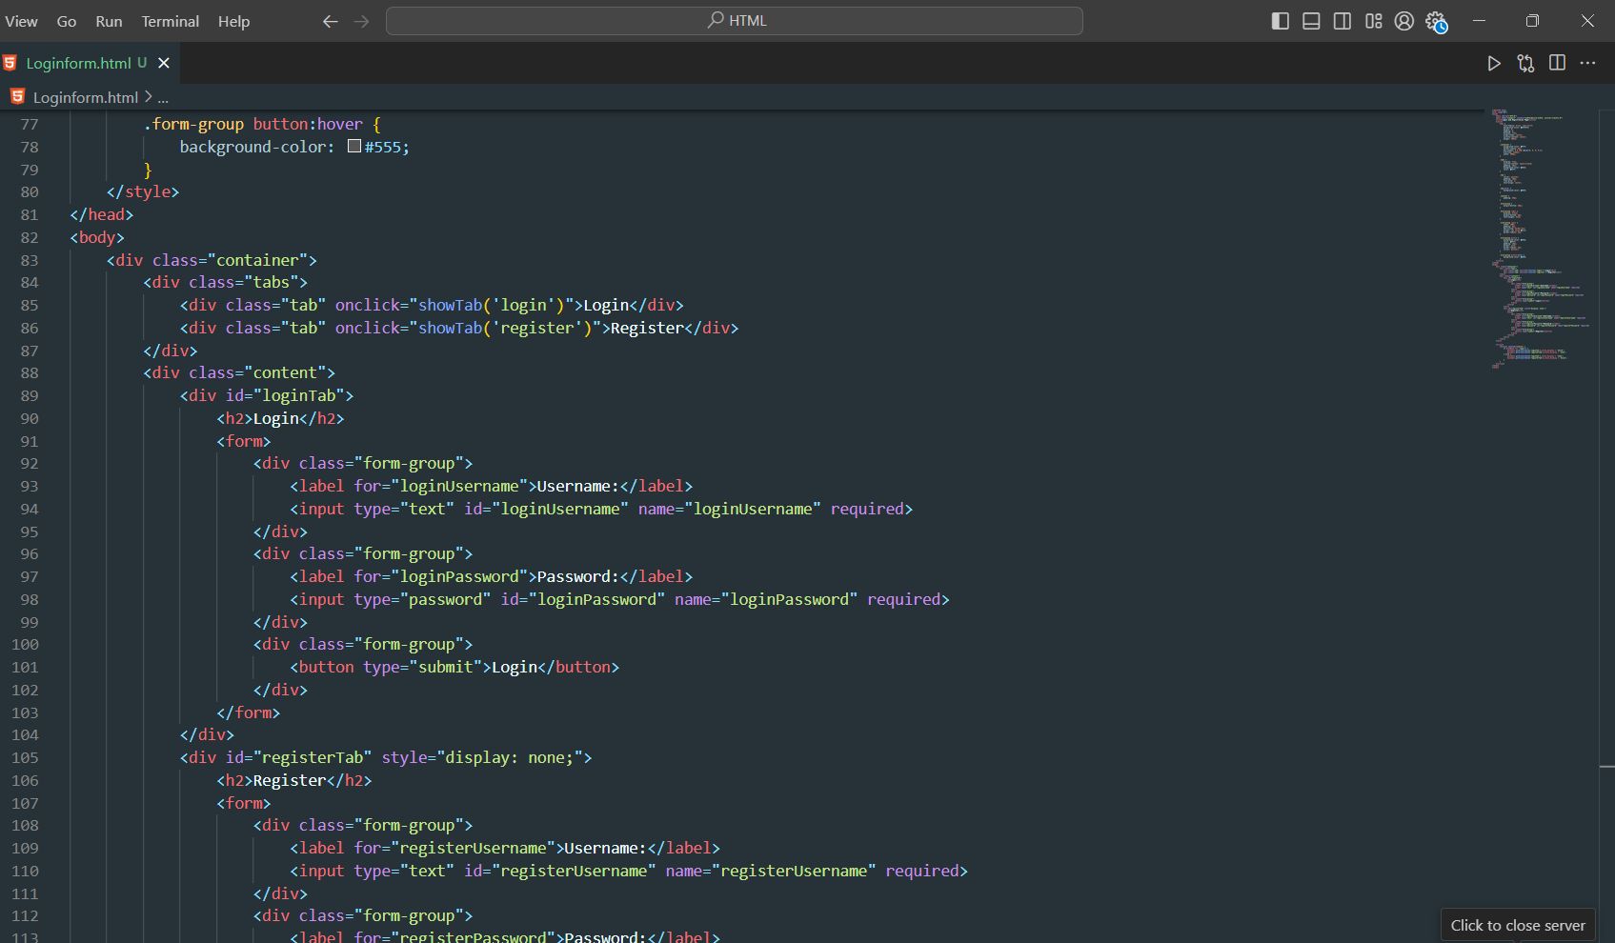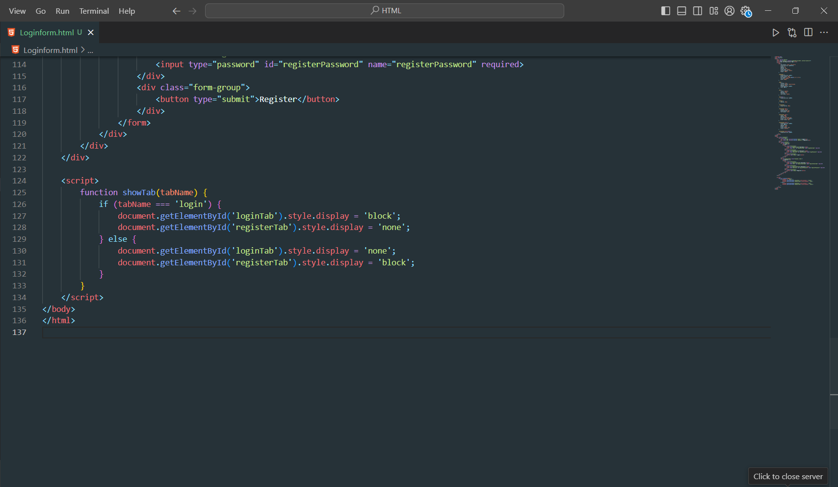

**Module – 2 Advance JavaScript**

1. **Calculate subtotal price of quantity in JavaScript?**

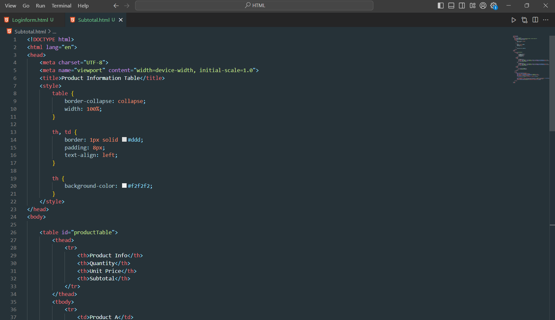

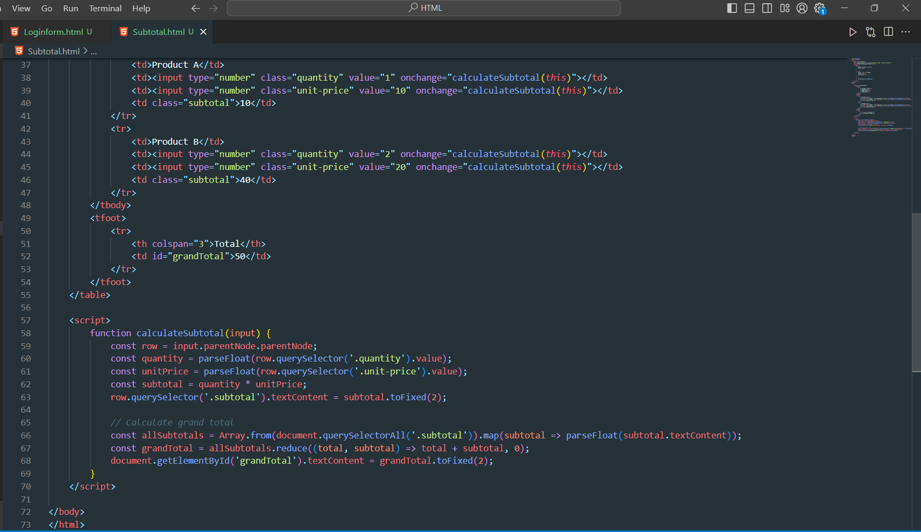

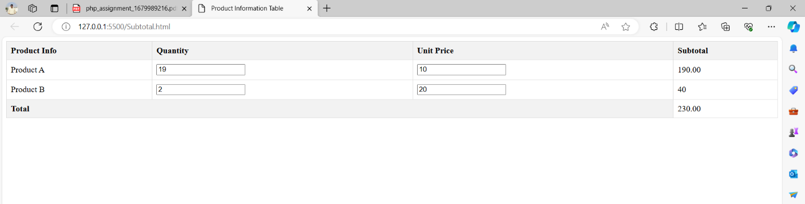

1. **What is JavaScript Output method?**

* In JavaScript, there are several methods for producing output or displaying information. The most common methods include:
* **Console.log():**

console.log("Hello, World!");

* **Alert():**

alert("This is an alert message!");

* **Document.write():**

document.write("This is some content.");

* **InnerHTML:**

document.getElementById("myElement").innerHTML = "New content";

* **Console Methods (Other than log()):**

console.warn("This is a warning!");

console.error("This is an error!");

1. **How to used JavaScript Output method?.**

* Using JavaScript output methods involves incorporating JavaScript code within HTML or within a JavaScript file. Below are examples of how to use the various JavaScript output methods:
* **Console.log():**

<script>

console.log("Hello, World!");

</script>

* **Alert():**

<script>

alert("This is an alert message!");

</script>

* **Document.write():**

<script>

document.write("This is some content.");

</script>

* **InnerHTML:**

<div id="myElement"></div>

<script>

document.getElementById("myElement").innerHTML = "New content";

</script>

1. **How to used JavaScript Events to do all examples?**

* **Console.log() with Button Click:**

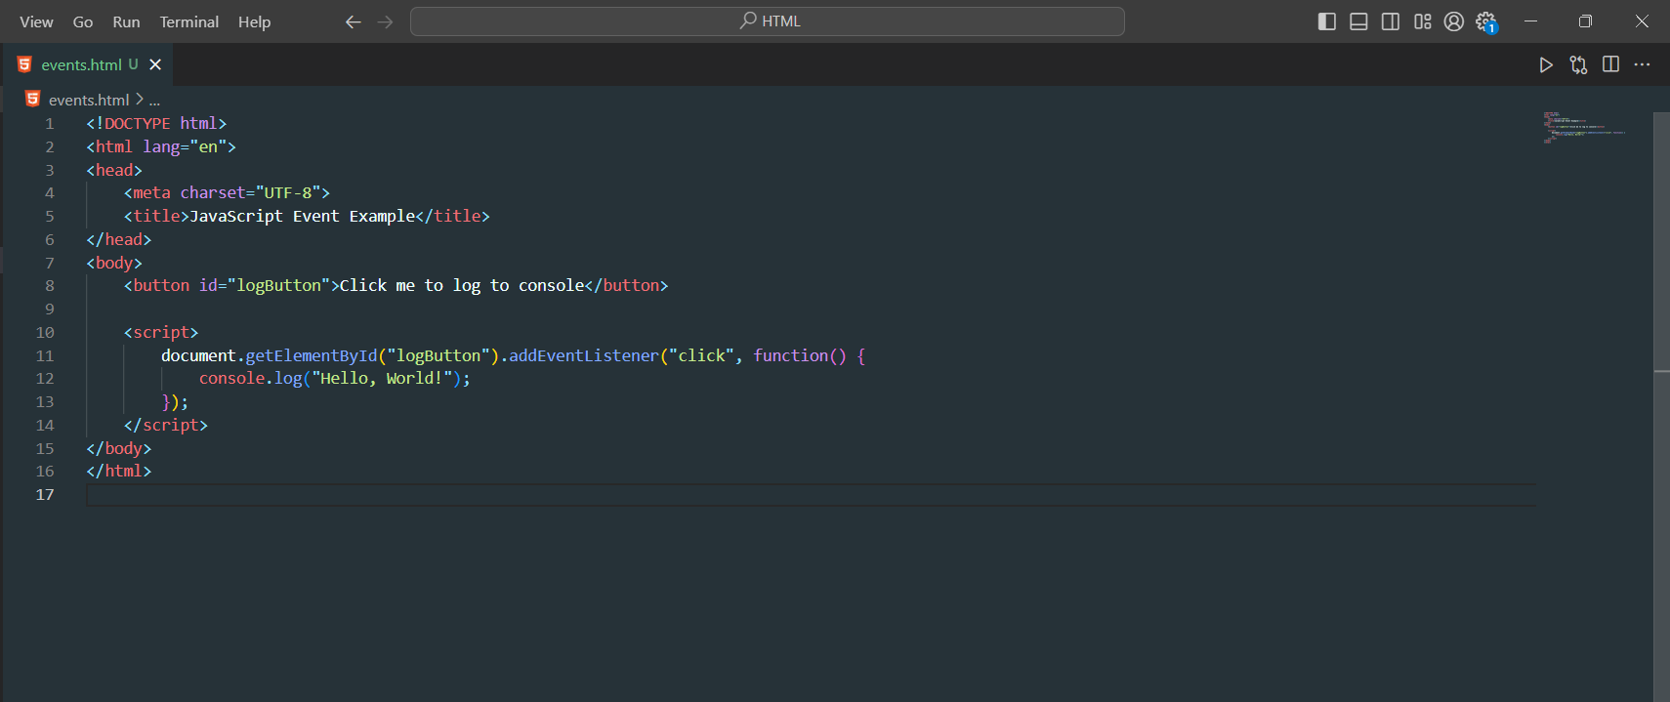

* **Alert() with Page Load:**

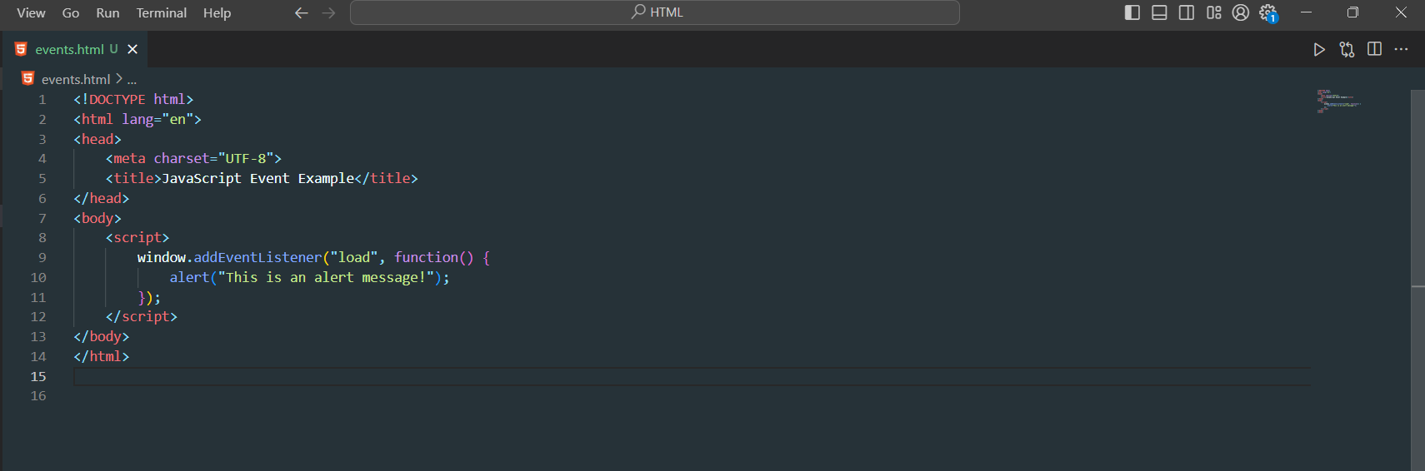

* **Document.write() with Button Click:**

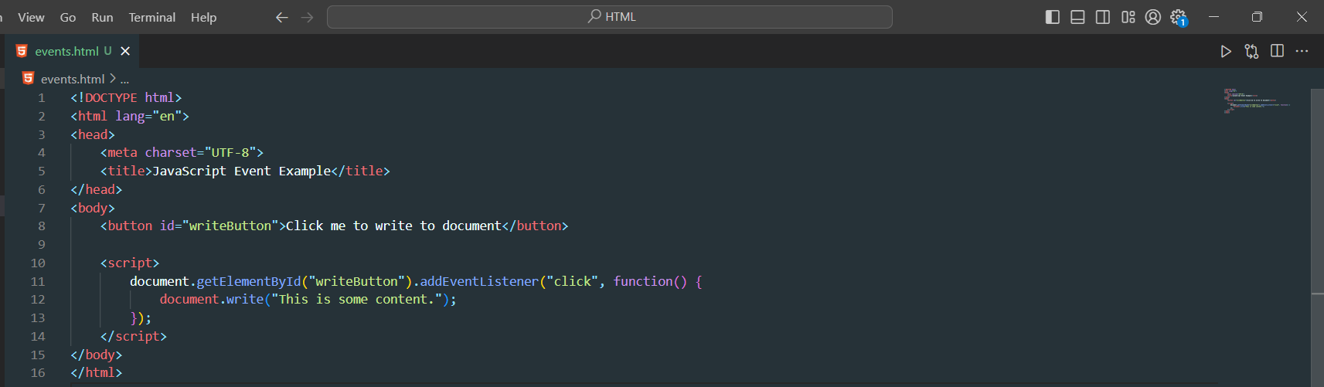

* **InnerHTML with Input Change:**

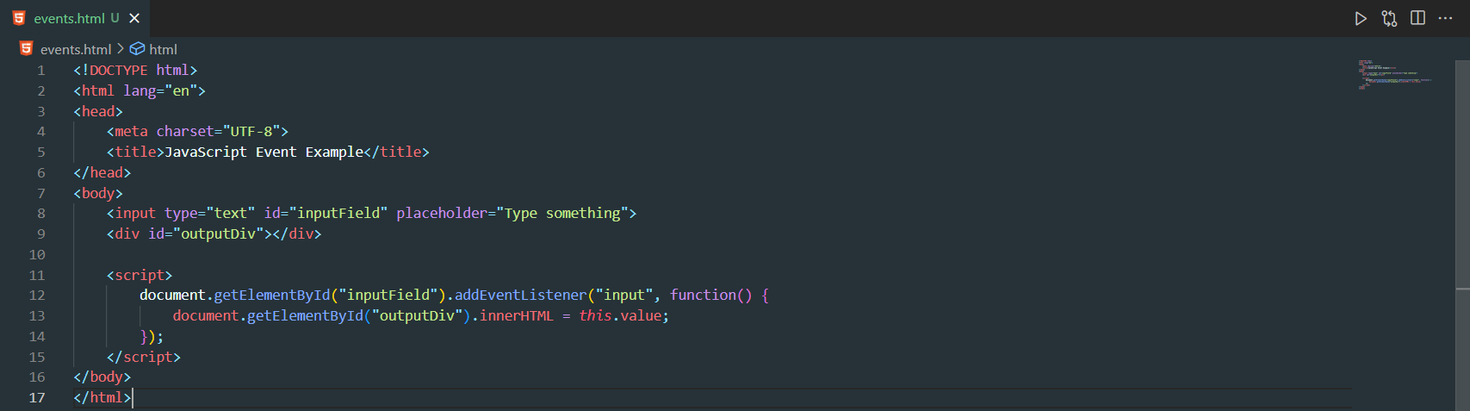

**Module – 3 ReactJs**

1. **What is React Js?**

* React.js, commonly referred to as React, is an open-source JavaScript library developed and maintained by Facebook. It is used for building user interfaces, particularly for single-page applications where UI updates are frequent. React allows developers to create reusable UI components and efficiently update and manage the state of the application

1. **What is NPM in React Js?**

* NPM stands for Node Package Manager, and it is the default package manager for Node.js. In the context of React.js, NPM is commonly used to manage and install packages and dependencies for React applications.
* These are just a few aspects of how NPM is used in the React.js ecosystem. The ability to manage dependencies efficiently is crucial in modern web development, and NPM is a key tool for achieving this in the Node.js and React ecosystem.

1. **What is Role of Node Js in react Js?**

* Node.js and React.js are often used together in web development, but they serve different purposes within a web application.
* while React focuses on building the user interface and components of a web application, Node.js plays a crucial role in the overall development and deployment process. It handles server-side rendering, serves as a development server, manages dependencies, and can be used for building backend services that complement React front-end applications. Together, they provide a powerful and efficient environment for building modern web applications.

1. **What is CLI command In React Js?**

* In React.js, the CLI (Command Line Interface) plays a crucial role in creating, building, and managing React applications. There are several CLI commands that are commonly used with popular tools like Create React App (CRA) to streamline the development process.

1. **What is Components in React Js?**

* In React.js, a component is a fundamental building block used to create user interfaces. A React component is a reusable, self-contained piece of code that defines a part of a user interface. Components can be thought of as custom, encapsulated HTML elements that can manage their own state and properties.

1. **What is Header and Content Components in React Js?**

* **Header Component:**

The "Header" component typically represents the top section of a web page or application. It often contains elements such as a navigation bar, a logo, links, or any other content that is intended to be displayed at the top of the UI.

* **Content Component:**

The "Content" component typically represents the main section of a web page or application where the primary content is displayed. This can include various components, widgets, or sections that make up the core content of the page.

1. **How to install React Js on Windows, linux Operating System? How to install NPM and How to check version of NPM?**

* **Install React.js on Windows:**
* npm install -g create-react-app
* npx create-react-app my-react-app
* cd my-react-app
* npm start
* **Install React.js on Linux:**
* sudo apt update

sudo apt install nodejs npm

* sudo npm install -g create-react-app
* npx create-react-app my-react-app
* cd my-react-app
* npm start

1. **How to check version of React Js?**

* To check the version of npm, run the following command in the terminal or command prompt:
* npm -v

1. **How to change in components of React Js?**

* **Locate the Component File:**

Identify the component you want to change, and locate its corresponding file in your project. React components are often defined in separate files, and their names typically end with .jsx or .js extension.

* **Make Code Changes:**

Open the component file using a code editor, and make the necessary changes to the component's code. You can modify the JSX structure, update the component's logic, add new elements, or make any other necessary adjustments.

1. **How to Create a List View in React Js?**

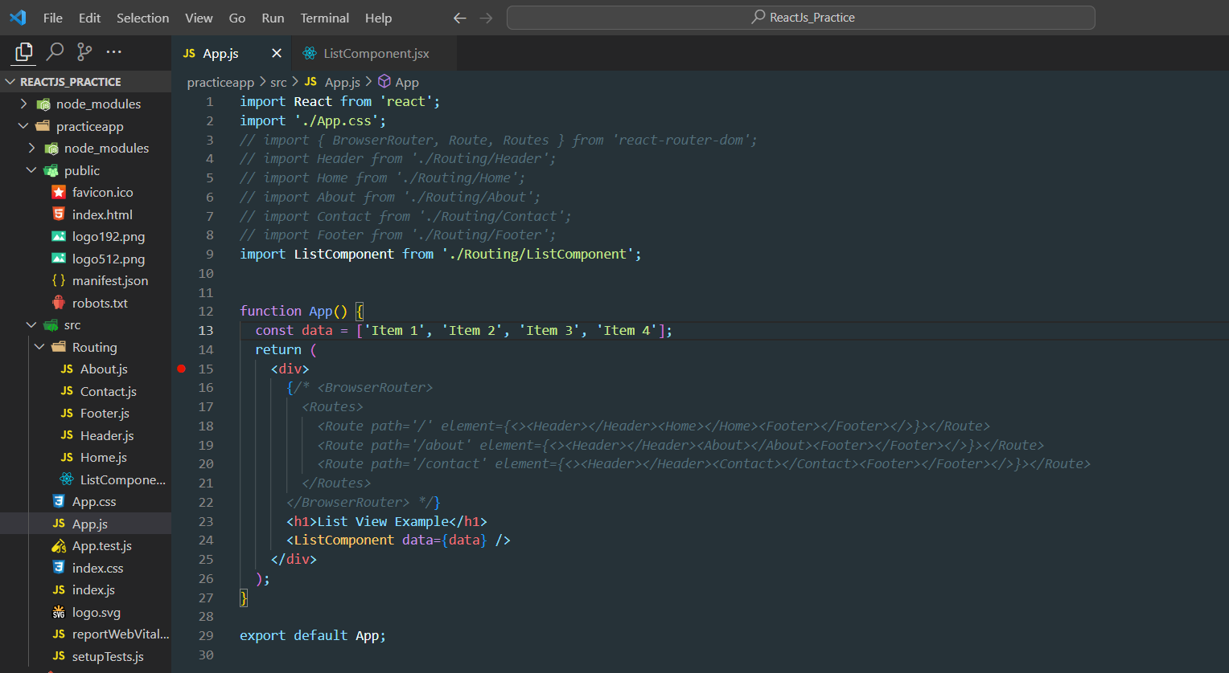

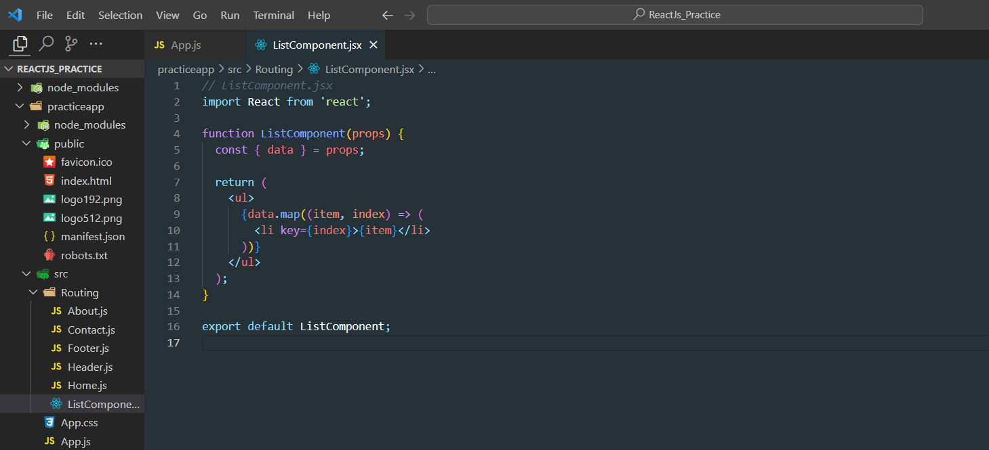

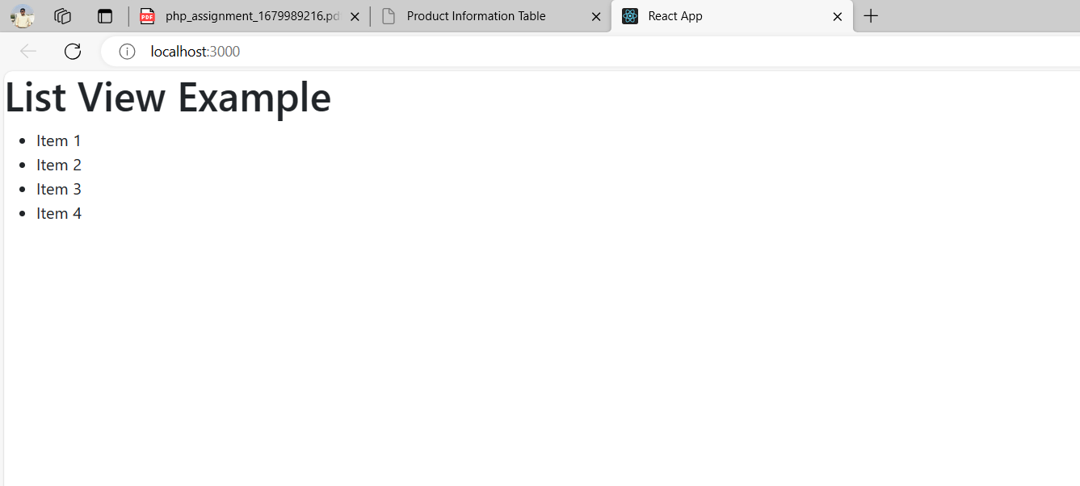

1. **Create Increment decrement state change by button click?**

